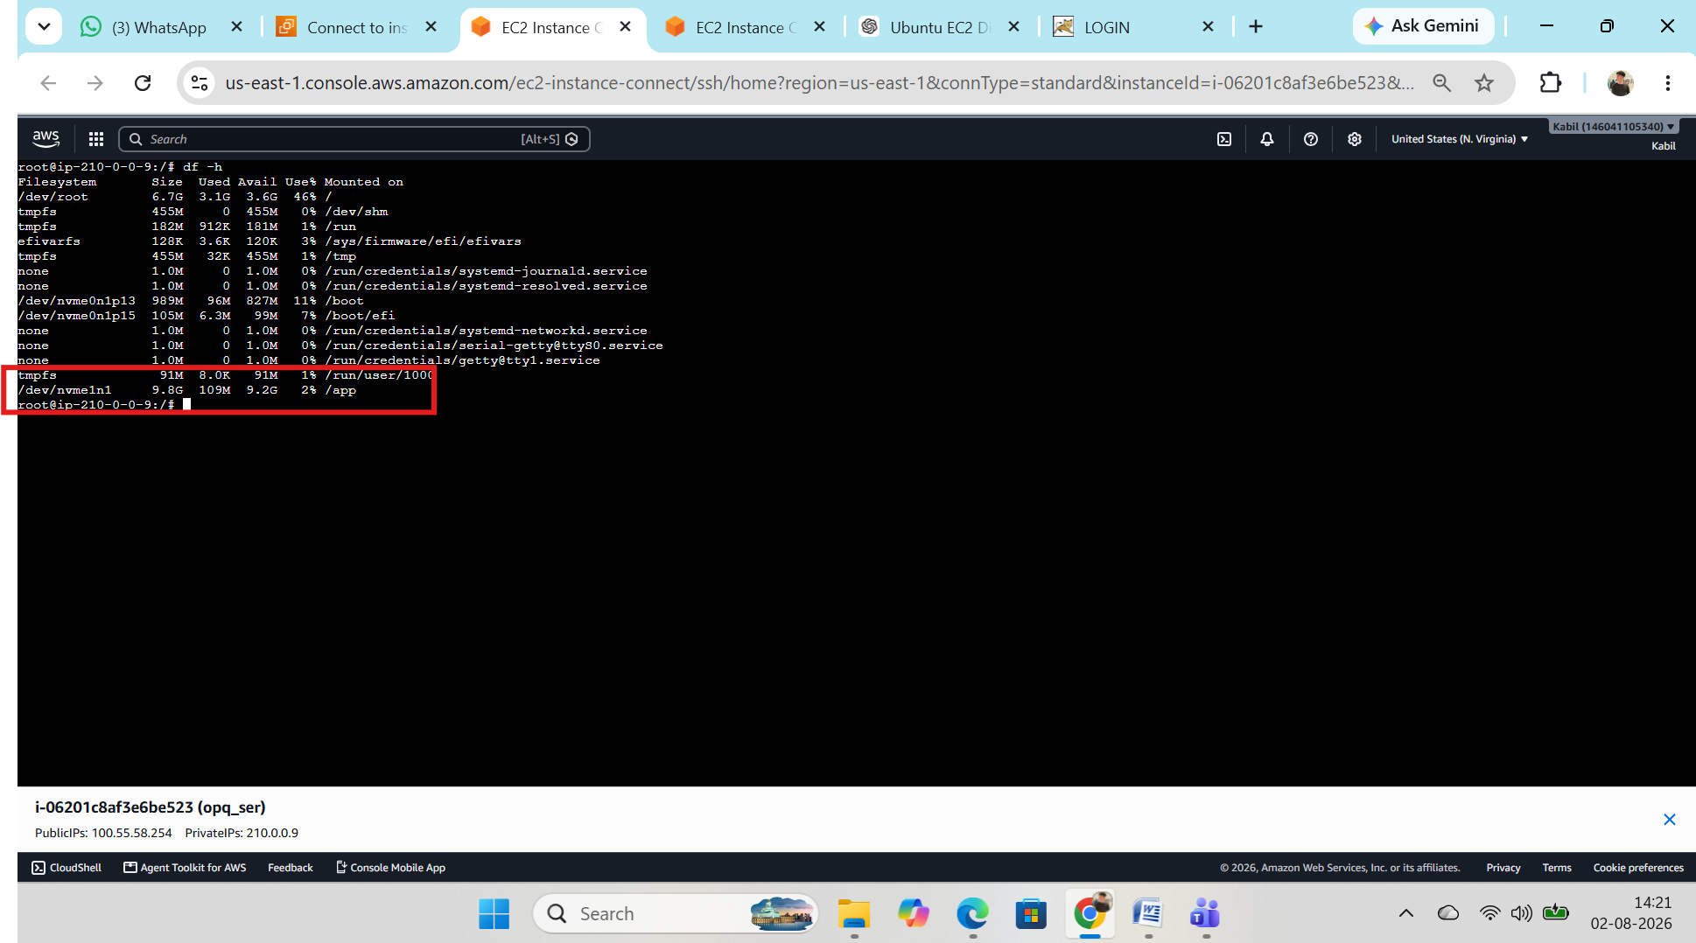
Step 1: Create an additional volume and attach to instance created filesystem(ext4) for new volumes and mount on /app .

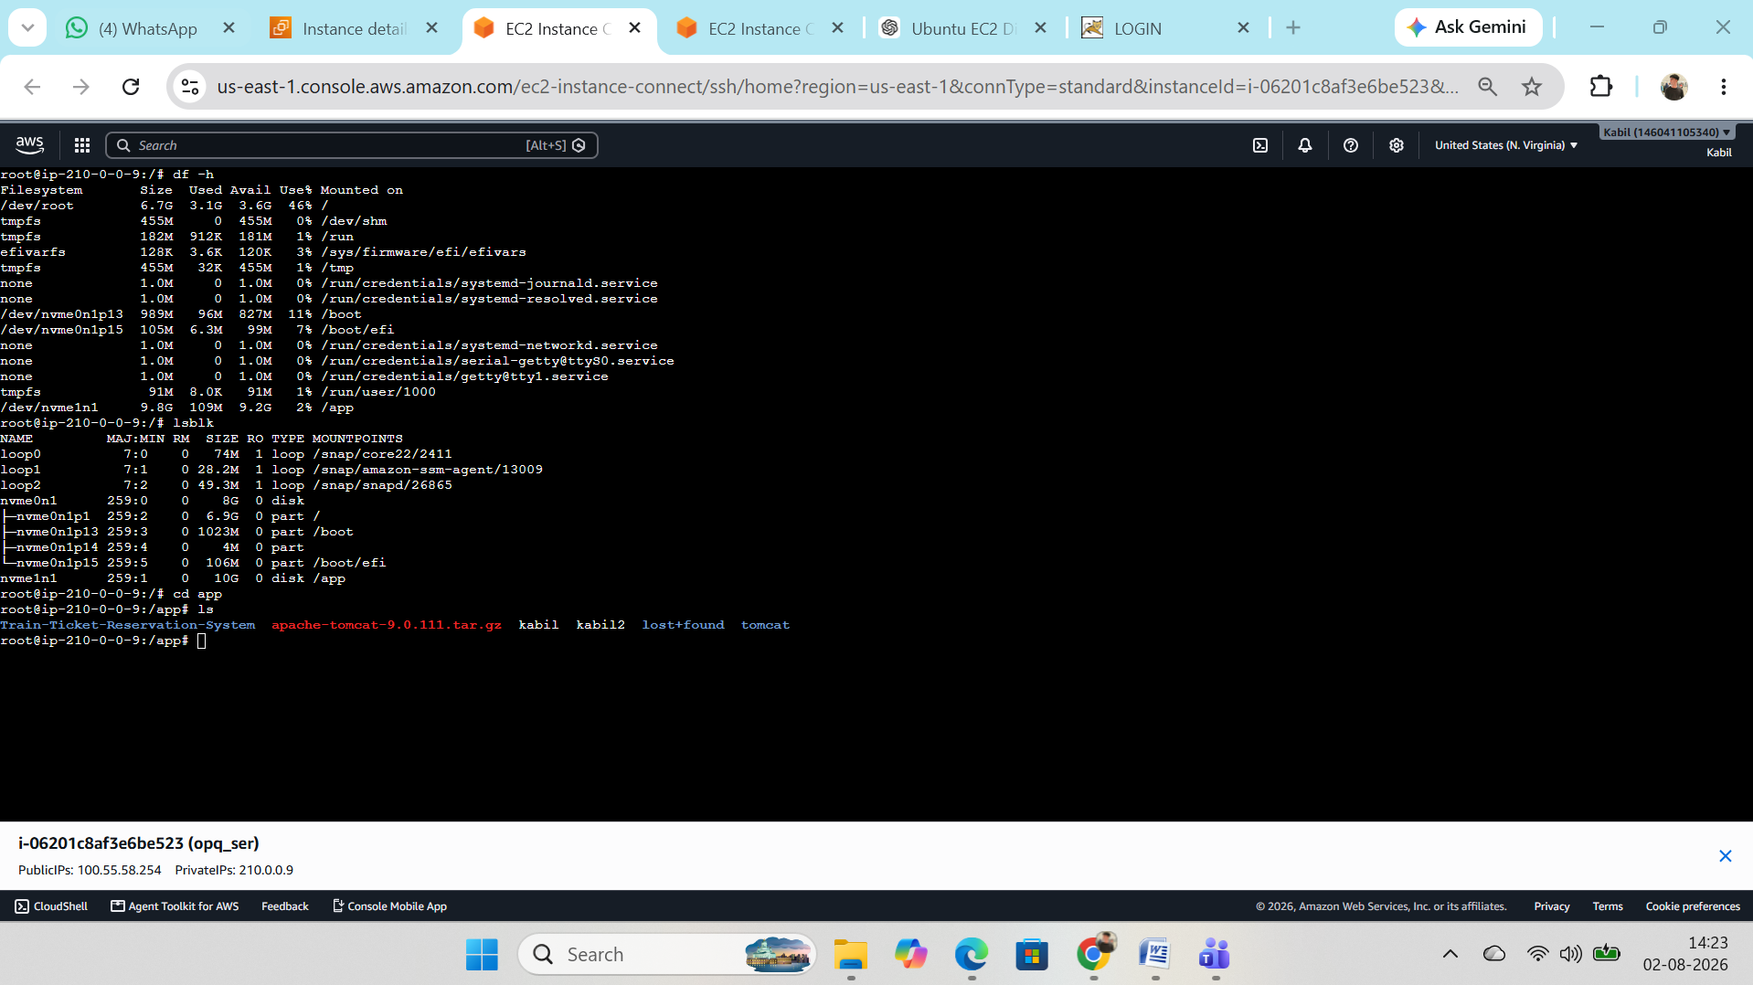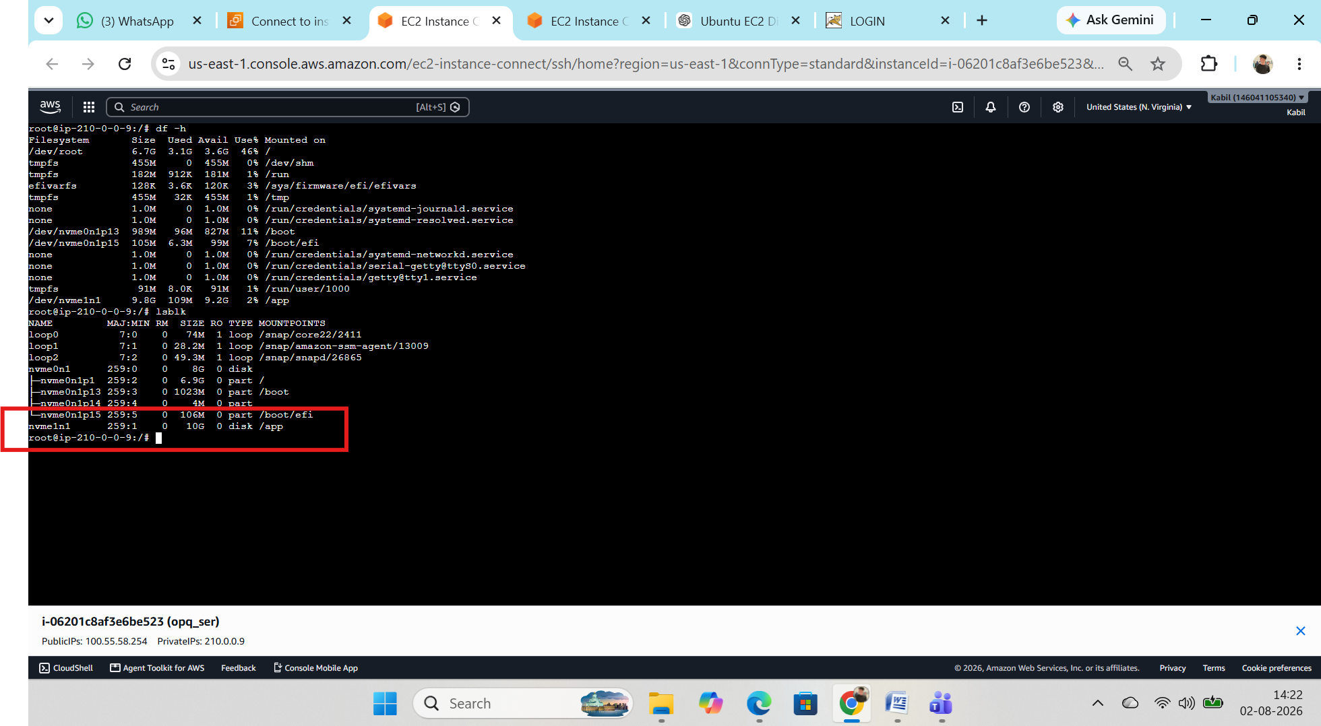
Step 2: Install java , maven, git and tomcat in /app directory additional volumes and run the service
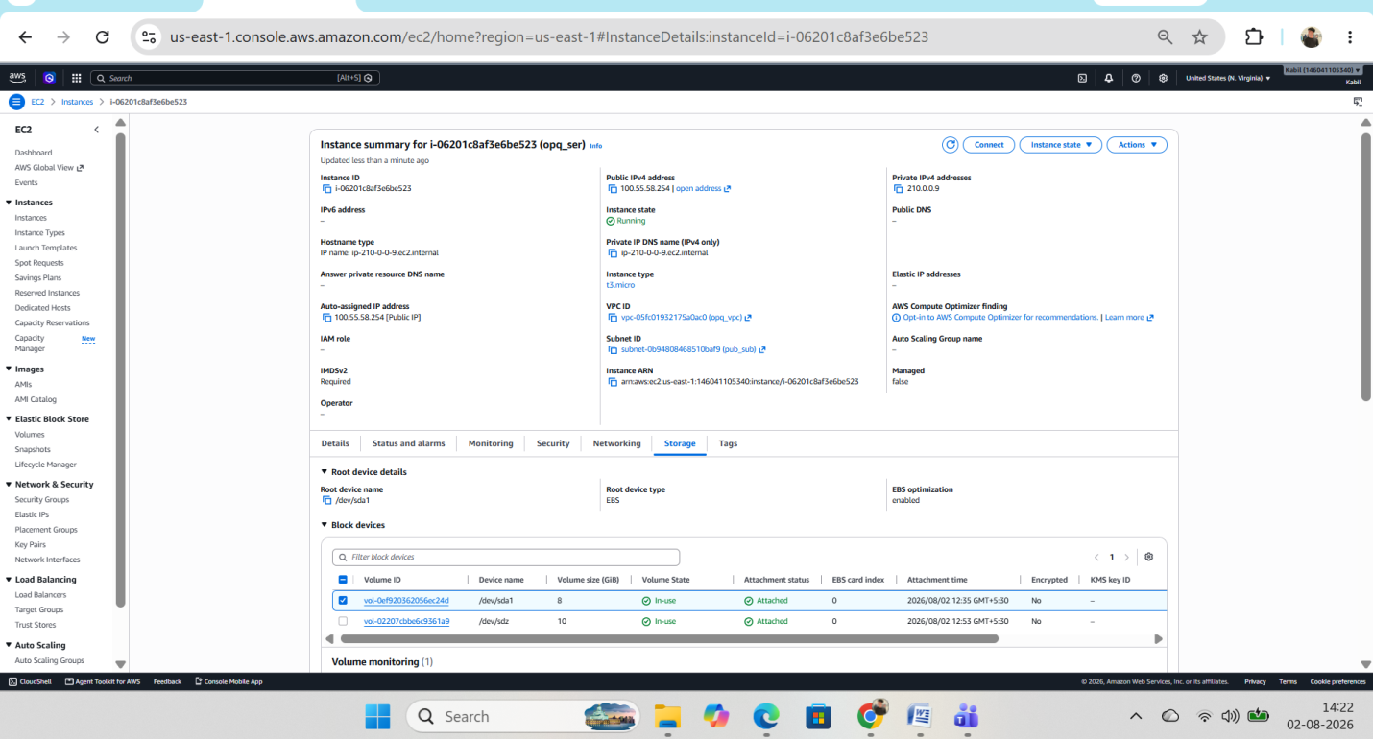
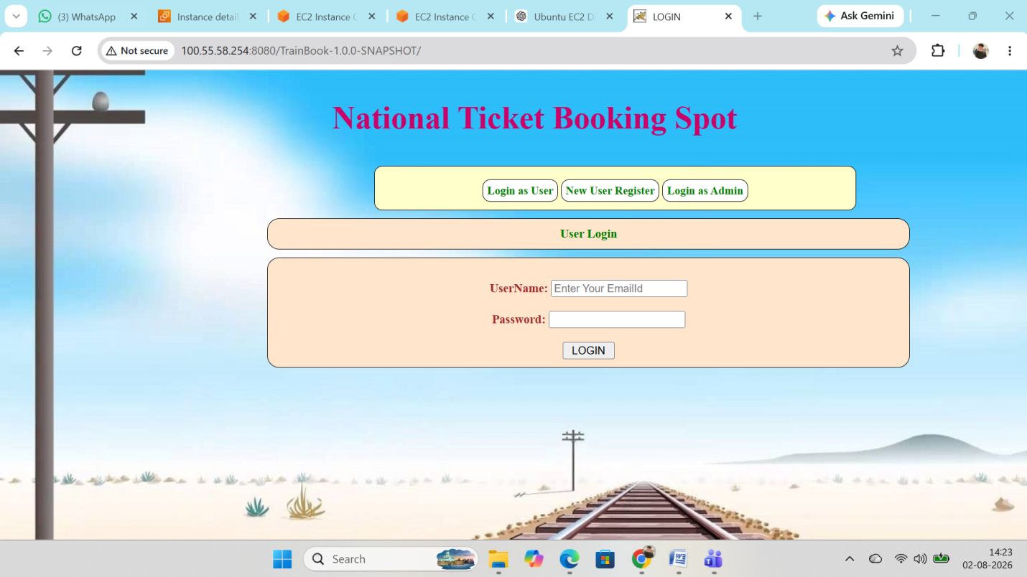
Step 4: Its running on 8080
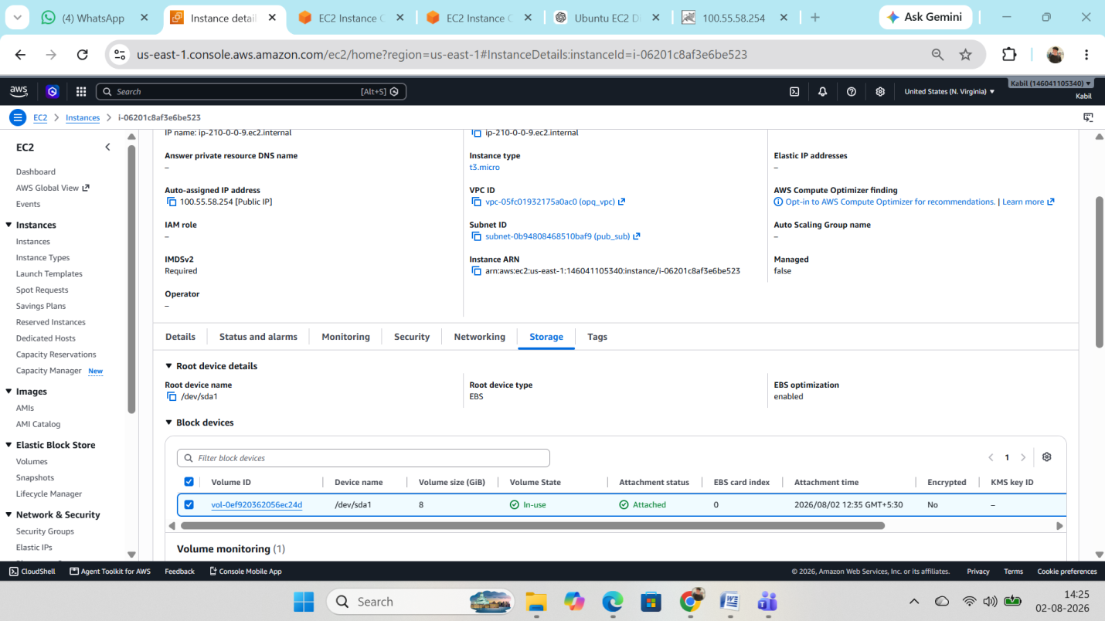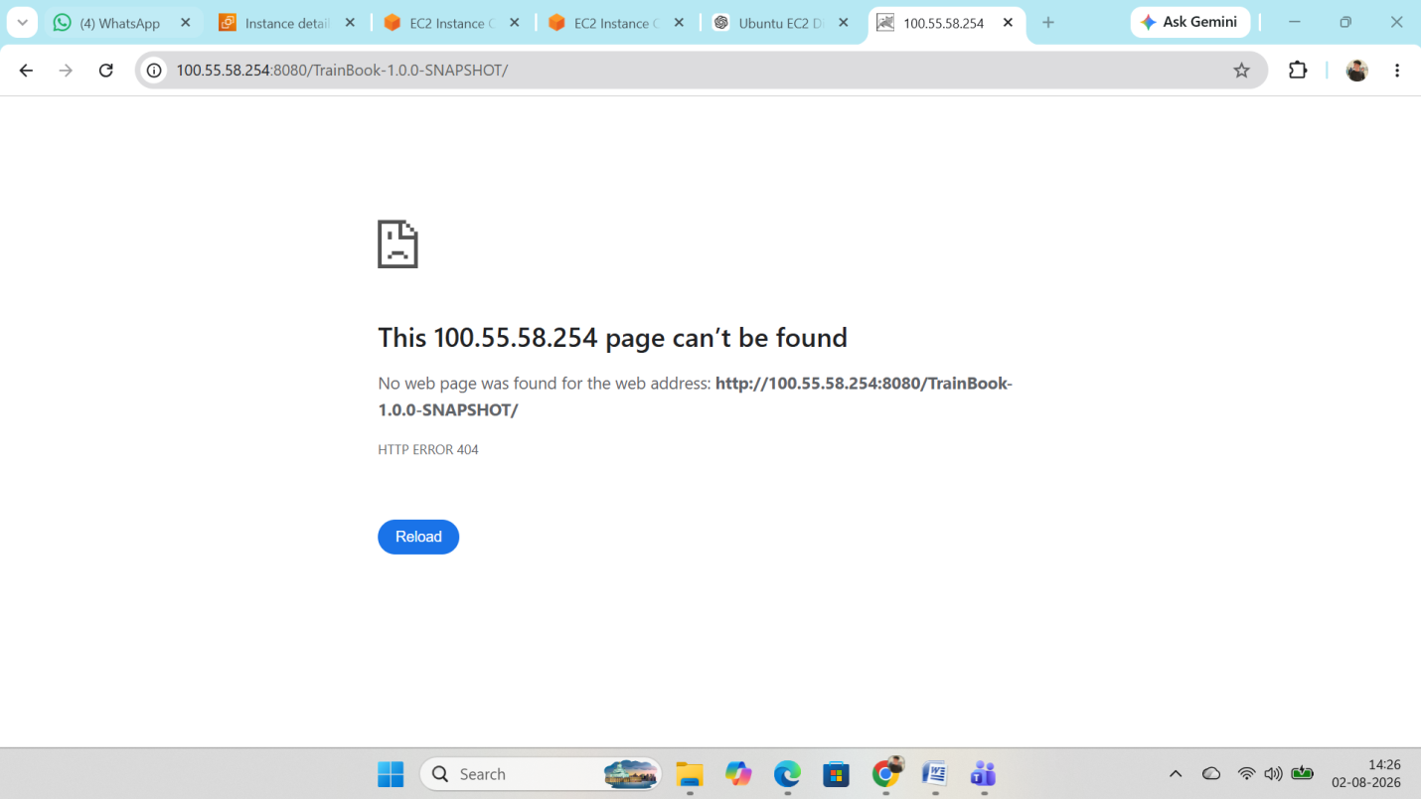

Step 5: After detach the volume from ec2 sevrice has been not reached because tomcat is stored on additional ebs.
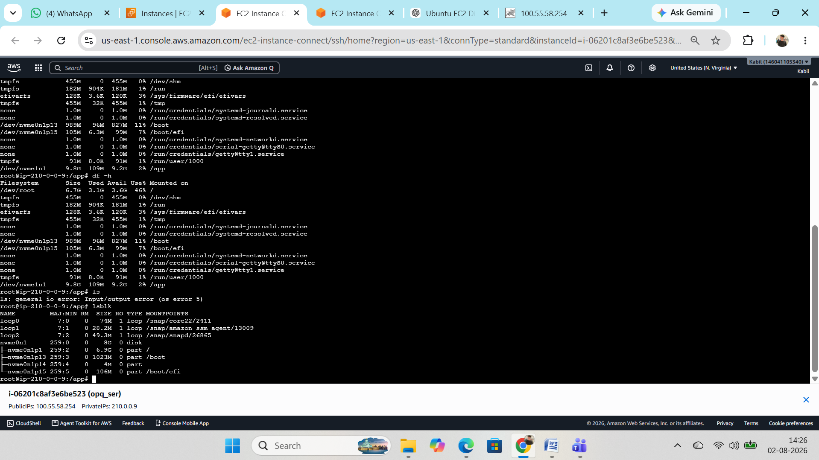

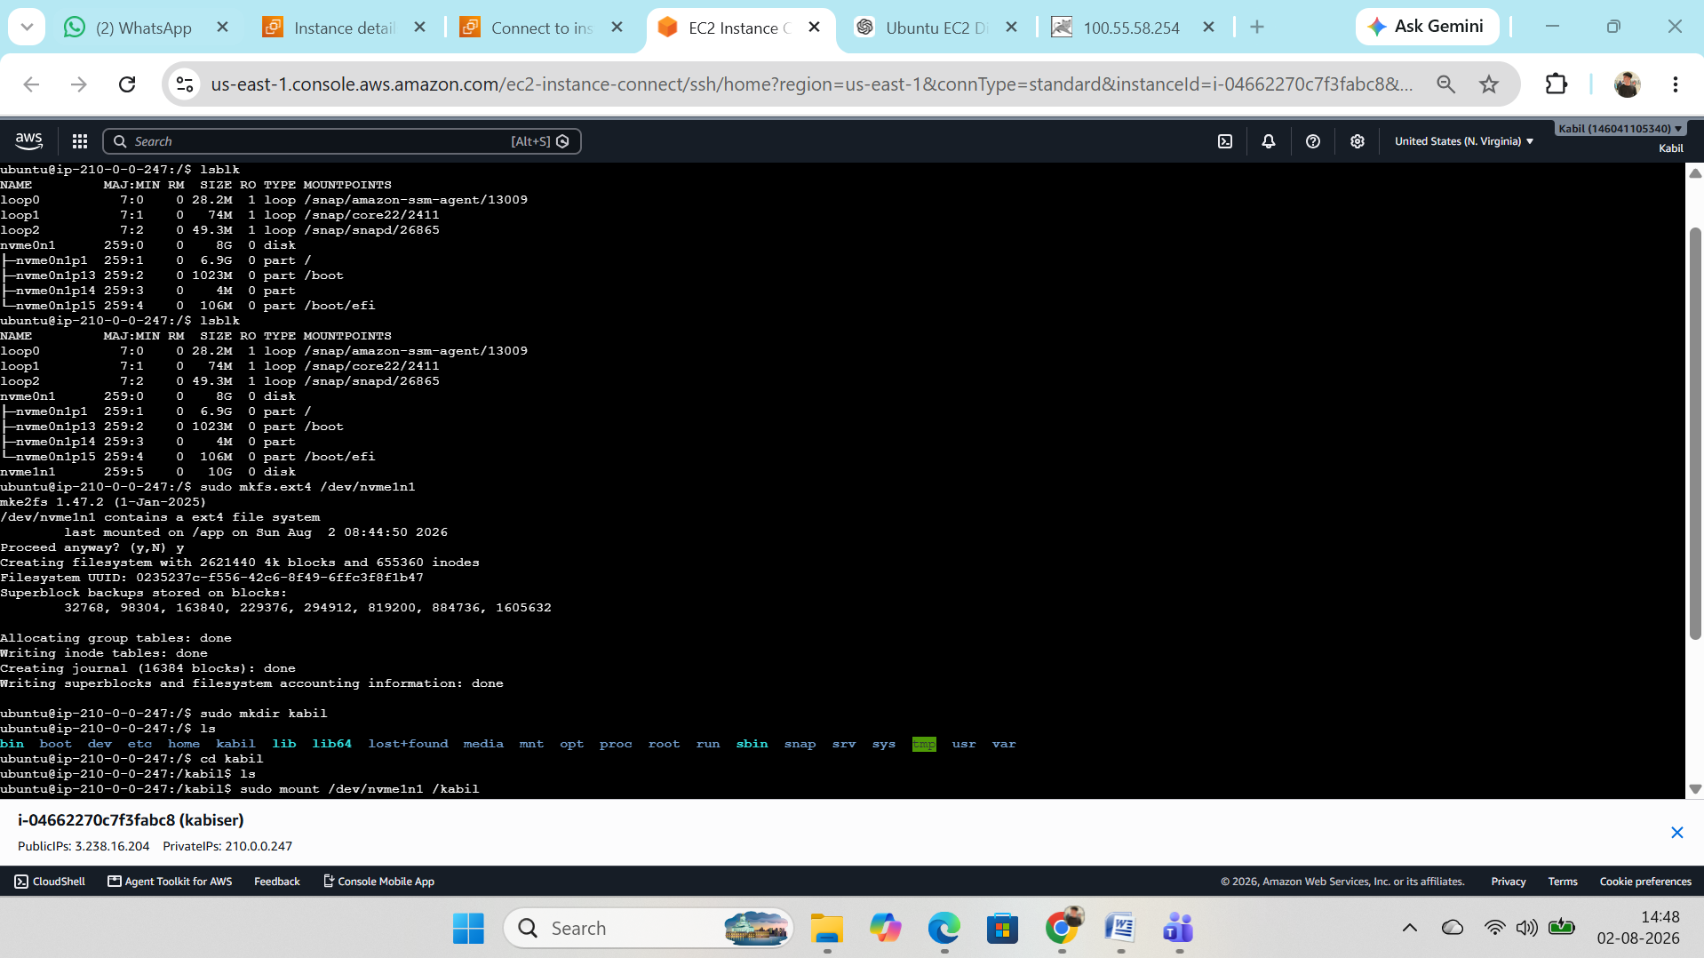

Step 6 :Create an new ec2 and attah the same volume and mount it new directory.

